August 18, 2023. To,
NIHVA Technologies Pvt. Ltd 187, G-Block, Thermax chowk, MIDC Chinchwad, Pune - 411019

Kind Attn:- Mr. Prasad J Deshmukh

Sub – Budgetary quotation for telescopic belt conveyor.

Dear Sir,

Thanks for your valuable enquiry for above said product, please find our offer as per your requirement.

Content of Proposal
Design, Manufacturing, Supply and Installation & commissioning of telescopic conveyor

Sr. no | Description | QTY | Basic Price in INR per unit
01 | Telescopic belt conveyor  - Conveyor height – 600 mm minimum to 1300 mm maximum  - Conveyor length – 1400 mm fix and can be expanded up to 1000mm  - PVC conveyor belt width – 450mm  - PVC belt thickness – 3 mm thk | 1 no. | 9,52,250/- + gst extra
Note – Conveyors will run at constant speed. No VFD is considered for conveyor. HSN code - 8466 3020


Specification of telescopic belt conveyor

- Flat belt Conveyor –T Length 2400 mm * Width 450 mm

- Length Fixed – 1400 mm

- Length Expandable- 1000 mm

- Width – 450 mm

- Height Fixed – 600 mm

- Expandable Height – 700 mm

- Maximum vertical height – 1300 mm

- Belt – PVC, 2-3 mm thick

- Constant Speed- 10 Mtr/ min

- Load Carrying Capacity Is 150 Kg

- MOC – MS Powder Coated

- Structure – Sq. tube 50 x 50 mm

- Top on-platform 3 mm thick Chequered Plate mounting

- Vertical Movement will be 700 mm stroke

- Horizontal Movement will be 1000 mm stroke @ 11° slop.

- Vertical and horizontal movement by electrically

- Electric panel – ON/OFF Switch, Start /Stop Switch, Emergency Switch,
- Small electric panel will mount on the frame.

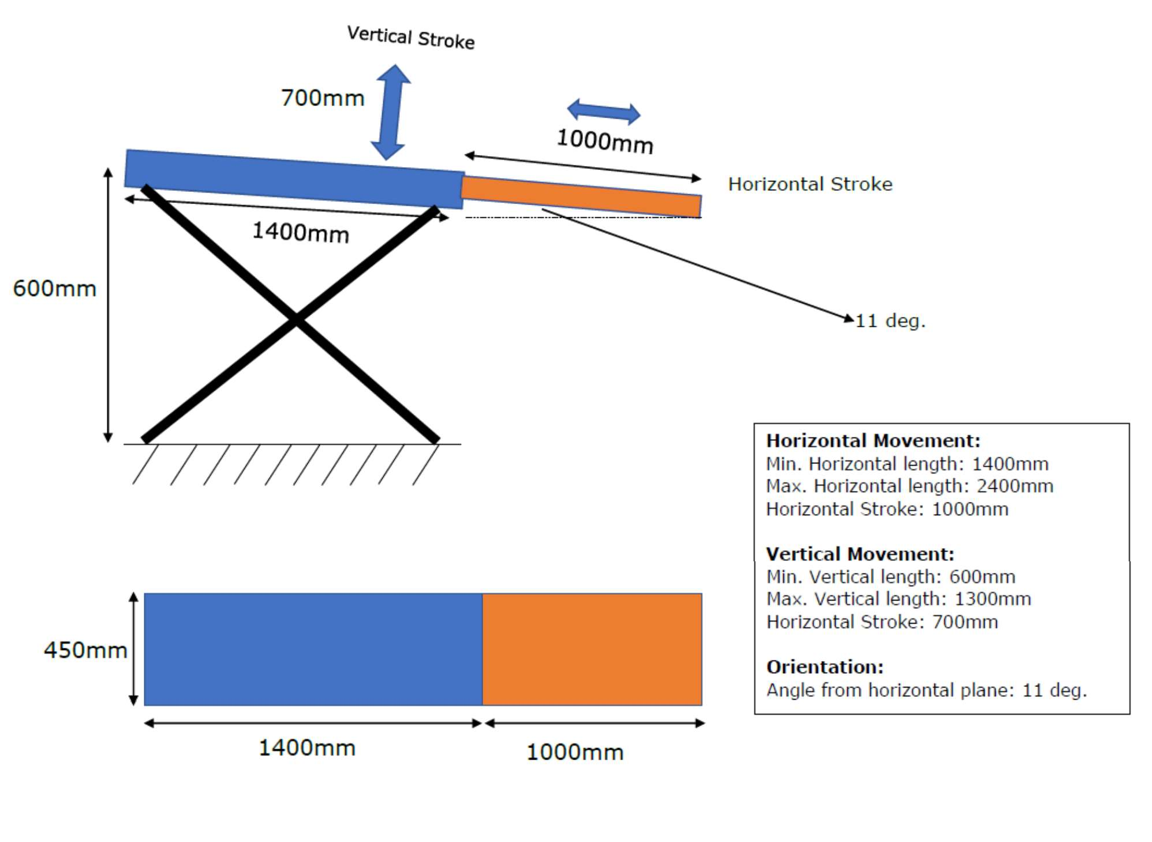

Make of Major bought out items

Sr. No. | Part description | Make
1 | Induction motor | Crompton Greaves / Havells / Reputed make
2 | Gear box | Bonfiglioli / Reputed make
3 | Sensors | Omron / Reputed make
4 | Limit Switch | Teknic / Ideal / Reputed make
5 | Relay board | Omron / Reputed make
6 | MCB / MPCB | Siemens / Reputed make
7 | PLC | Siemens / Reputed make
8 | Wires and cables | Polycab / Reputed make
9

TERMS AND CONDITIONS OF BUSINESS:

- All rates are ex-works Bhosari.
- Taxes – SGST @9 % and CGST@ 9% or as applicable at the time of dispatch.
- Packing & Forwarding – 2% of Offer Value.
- Freight charges - 2% of Offer Value
- Transit Insurance to be borne by Purchaser.
- Dispatch – Will be delivered to your Pune plant.
- Delivery Period – 8-10 weeks.
- Payment terms: 50% advance along with PO, 40% of basic + taxes after approval to ship the conveyors before dispatch, 10% after installation & Commissioning or within 30 days of invoice, whichever is earlier.
- Warranty – 12 months from the date of Commissioning against any manufacturing & design defects/faulty workmanship for the material supplied.
- Installation & commissioning – Quoted separately
- Unloading of dispatched items is not in ISRIPL scope.
- Removing of existing items are not in ISRIPL scope.
- Fitment of existing items OR removed items is not in ISRIPL scope.
- Grouting of Existing items is not in ISRIPL scope.
- Safety / security of Unloaded material and our tools and tackles responsibility is in customer’s scope.
- Welding / Fabrication help will be provided by customer as and when required and it will be free of cost.
- Quotation validity: 30 days from its date & subject to reconfirmation thereafter.

